Engineering Club
Telescope Motorization Project - Fall Semester 2014

Project Objective:
Modify an existing telescope for motorized control to locate and track stars and other celestial objects from an object database or from manually-entered coordinates.

Fall Semester Objective:
Install motors and gears and demonstrate software-controlled motion.
Demonstrate repeatable positioning and star tracking.

Project Background and Motivation:
PCC math and astronomy professor John Sepikas wants to control remotely-stationed telescopes for observation and scientific data gathering. The ultimate hope is to place telescopes around the world which are self-mobilized and self-orienting and can be remotely operated by schools and scientists.

Telescope: Orion XT6 6-inch Dobsonian reflector telescope owned by John Sepikas.
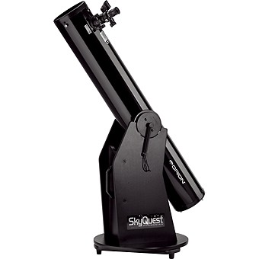
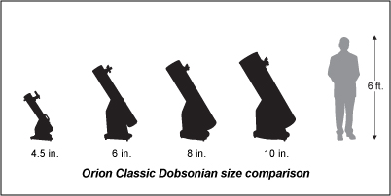

Core Team Members:
Chi Yeung Chiu (Mechanical System)
David Harbottle (Mechanical System, Electrical System)
Moses Audi (Software System)
Peter Ngo (Mentor / Project Manager) pngo@gatech.edu

We are looking to add 2-3 Engineering Club members to the team for work this fall semester. However, we will attempt to keep all interested Club members involved by inviting them to attend project meetings and presentations at Engineering Club.

Please submit applications by Friday, September 26, at the Engineering Club meeting or drop it in the submission box in IT 117 (Fab Lab).
Engineering Club
Telescope Motorization Project - Fall Semester 2014 Application Form

Name __________________________ E-mail __________________________

Major __________________________ Year __________________________

Interested in (select one or more):
___ Mechanical (gears, mounts, CAD, fabrication)
___ Electrical (power circuitry, battery) & Electronics (microcontroller/computer, motors, sensors)
___ Software (motor control, feedback control, celestial object database)

Do you have experience in any of the following?:
___ SolidWorks ___ Autodesk Inventor ___ Other CAD: ___________________________
___ Machine tools ___ 3D Printer ___ Laser cutter
___ DC motor theory (torque, speed, power, voltage, current) ___ Gear train design
___ Arduino ___ Raspberry Pi ___ Other microcontrollers: ____________________________
___ Encoders ___ Feedback control
___ Programming language(s): _______________________________

List your current extra-curricular activities:

Briefly describe any robotics or electronics projects you have worked on previously:

Explain your interest in this project:

Please attach your current class schedule to this application.

